Pizza Sales Analysis using SQL

Key Performance Indicators:

1. Total Revenue

/*Total Revenue*/

select round(sum(total_price),2) as `Total_Revenue` from Pizza_Sales



1. Average Order Value:

/*Average Order value*/

select round((sum(total_price) / count(distinct order_iD)),2) as `Average_Order_value` from Pizza_Sales;



1. Total Pizza Sold:

/*Total Pizza Sold*/

select sum(quantity) as `Total_Pizza_Sold` from Pizza_Sales;



1. Total Order Placed:

/*Total Order Placed*/

select count(distinct order_id) as `Total_Order_Placed` from Pizza_Sales;



1. Average sale count Per Order:

/*Average sale count Per Order*/

select round(cast(sum(quantity) as decimal(10,2)) / count(distinct order_id),0) as `Average_sale_count_Per_Order` from Pizza_Sales;



Pizza Sales Analysis using SQL

Understanding Key Charts to visualize:

1. /*Daily Trend for Total Orders*/

select dayname(order_date) as Order_day, count(distinct order_id) as Order_count from pizza_sales

group by order_day

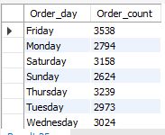

1. /*Hourly Trend for Total Orders*/

select hour(time(order_time)) as Order_Hour, count(distinct order_id) as Order_count from pizza_sales

group by Order_Hour

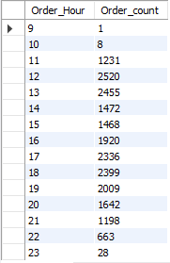

1. /*Percentage of Sales by Pizza Category*/

select pizza_category, round(Sum(total_price),2) as Total_Sales, round(sum(total_price) * 100/ (select sum(total_price) from pizza_sales),2) as Percent_of_Sales from pizza_sales group by pizza_category

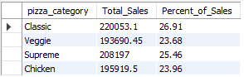

1. /*Percentage of Sales by Pizza Size*/

select pizza_size, round(Sum(total_price),2) as Total_Sales,round(sum(total_price) * 100/ (select sum(total_price) from pizza_sales),2) as Percent_of_Sales from pizza_sales group by pizza_size;

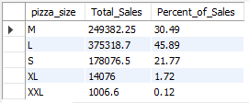

1. /*Total Pizzas Sold by Pizza Category*/

select pizza_category, round(sum(quantity),2) as Total_Quantity,round(sum(quantity) * 100/ (select sum(quantity) from pizza_sales),2) as Percent_of_Sales_quantity from pizza_sales group by pizza_category;

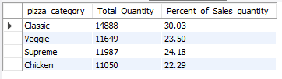

1. /*Top 5 Best Sellers by Total Pizzas Sold*/

select pizza_name, sum(quantity) as Total_Quantity_sold from pizza_sales group by pizza_name

order by Total_Quantity_sold desc limit 5;

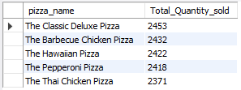

1. /*Bottom 5 Worst Sellers by Total Pizzas Sold*/

select pizza_name, sum(quantity) as Total_Quantity_sold from pizza_sales group by pizza_name

order by Total_Quantity_sold asc limit 5;

